TITLE III Application Instructions 2021 – 2022

  - LANGUAGE INSTRUCTION for English Language Learners

Title III Application Instructions
2021-22
Table of Contents

Overview of Title III & Required Expenditures Page 2
Supplement/ supplant Page 4
Allowable Title III Expenditures & Application Details Page 5
Application Details, Budget Tips, and Document Library Page 7
Private School Consultation Page 10
Consortium Requirements Pages 11

Contact Information:
Emily Klein Emily.klein@ride.ri.gov 222-8985
Flavia Molea Baker Flavia.MoleaBaker@ride.ri.gov 222-8480
Veronica Salas Veronica.Salas@ride.ri.gov 222-8939

TITLE III Application Guidance FY 2021-22

LANGUAGE INSTRUCTION FOR English Language Learners

Overview of Title III

Title III is a federal formula grant program that makes supplemental funds available to local school districts based on the number of EL students enrolled in the district and in Private Schools located in the district. The purpose of the program is to ensure that these students are prepared to meet the English language proficiency standards as well as the same challenging state academic content and grade level performance standards expected of all other students.
Three required supplemental expenditures under Title III are:
- professional development for all teachers of ELs, including EL and bilingual teachers, ELL teacher assistants, and content area teachers of ELLs that
  - Improves instruction and assessment of ELs
  - Enhances ability of teachers and principals to implement curricula, assessment measures and practices, and instructional strategies for ELs
  - Increases English proficiency or subject matter knowledge, teaching knowledge, and teaching skills of teachers of ELs
  - Is of sufficient intensity and duration to have a positive and lasting impact on the teachers’ performance in the classroom.
  - Definition of professional development:
    - Integral part of school and district strategies
    - Aligns to academic goals of school or district
    - Evaluated for impact on increased outcomes
    - Sustained, intensive, collaborative, job-embedded, data-driven, and classroom-focused with follow-up
    - Improves classroom management
    - Provide training in the use of technology, data, and assessments
    - Supports recruitment, hiring, training of effective teachers
    - Include instruction in ways that school personnel can work more effectively with parents and families
  - Improve and increase teachers of ELs
    - Knowledge of academic subjects that they teach
    - Understanding of how students learn
    - Ability to analyze student work and achievement from multiple sources
    - Ability to adjust instructional strategies, assessments, and materials based on such analysis

- language instruction educational programs (LIEPs) that facilitate improved English language proficiency and academic outcomes such as enhanced instructional opportunities, including specific instructional interventions to meet identified academic needs of ELs, or extended day, summer or ramp-up programs
- parent, family, and community engagement activities that enhance or supplement LIEPs for ELs
  - Community may include the local and extended network of organizations that exist to support the student and family and can include private, non-profit, for-profit, or faith-based organizations.
  - Families may include relatives involved in the social, emotional, and academic support of the student; it expands beyond parents and guardians to include siblings, grandparents, aunts, uncles, cousins and others.

Allowable supplemental expenditures for Title III include:
- community participation programs, family literacy services, parent outreach and training to ELs and their families,
- improving the instruction of ELs with disabilities
- linguistically appropriate materials, particularly those that address academic language development, educational technology and access to electronic networks
- LIEPs in preschools and early college high school or dual/concurrent enrollment programs or courses designed to help ELs achieve success in postsecondary education

What are the district’s responsibilities under the Title III program?

- provide programs and services that reflect scientifically based research regarding the education of ELs while permitting flexibility to the extent permitted under state law to select and implement activities in a manner that best reflects local needs and circumstances;
- ensure that programs and services are of sufficient scope and quality to carry out effective (educationally sound and proven successful) language instruction programs that assist English learners to increase English language proficiency and meet challenging state academic standards. Effective is defined as:
  - Driven by data on the unique needs of ELs including district subgroups of ELs
  - Aligned with local needs identified through timely and meaningful consultation with a broad range of stakeholders
  - Based on rigorous, relevant research
  - Accompanied by a robust plan for implementation including well-defined measurable goals, clearly outlined roles and responsibilities, implementation timelines
  - Examined through performance monitoring and evaluation including longitudinal data in order to make changes
  - Included as part of a systemic approach to serving ELs based on ELP standards and academic content standards
  - For preschool students, LIEPs should demonstrate improved learning outcomes for ELs. (ESEA Section 3115(a),(c))

- ensure that language instruction and other services are developmentally appropriate for young ELs, culturally responsive, reflective of the latest research on effective instruction for ELs in early learning programs, and supportive of all EL’s needs. An LEA should consider the developmental and language needs of children when determining which students may be served using Title III funds. For more information on promising practices to support young ELs, see www.acf.hhs.gov/sites/default/files/ecd/dll_policy_statement_final.pdf
- coordinate activities and share data with early childhood programs (ESEA Section 3116) should help lead to improved alignment across the early educational years and improved outcomes for ELs and facilitate a strong transition for ELs into elementary and secondary education. In determining which data would be most appropriate to share with early learning programs, including Head Start Agencies, we encourage LEAs to consult with and solicit feedback from early learning programs in the community. LEAs are encouraged to consider which indicators would be most beneficial to create a feedback loop that informs the improvement of programs and supports for ELs and to consider which data could most accurately be used to measure progress against such indicators. In considering whether to share or exchange student data, LEAs must comply with the Family Educational Rights and Privacy Act (FERPA).
- be accountable for meeting state-designed long-term goals established under ESEA Section 1111(c)(4)(A)(ii), including measurements of interim progress towards meeting such goals, based on the State’s English language proficiency assessment under ESEA Section 1111(b)(2)(G); and the challenging State academic standards ESEA Section 3111(b)(2)(E) ;
- annually assess the English-language proficiency of all ELs served through this program;
- annually assess progress of ELs toward meeting Language Arts and mathematics standards;
- form a consortium if the total amount of the district’s allocation is less than $10,000. See below for requirements;
- hold timely and meaningful consultation with appropriate private school officials in the geographic area served by the district, in order to provide funded services to the EL students and staff in those private schools, taking into account the total number of ELs and their educational needs. Evidence of consultation, number of ELs in private schools, and the district’s plan to evaluate participation in Title III services must be submitted on the private school participation form which can be found in the document library. Please upload this form on the Related Documents page of the EL/Title III Performance report.

Title III Supplement not Supplant Requirements

Title III is a supplemental program to provide services in addition to, but that do not to replace, core English language instructional programs. States, districts, and schools are required to provide core English language instruction programs and services for English Learners (ELs) based on Title VI of the Civil Rights Act of 1964, and its implementing regulations, as interpreted by the U.S. Supreme Court ruling in Lau v. Nichols, and the Equal Educational Opportunities Act of 1974. An LEA may not use Title III funds to pay for services that are necessary and required to be provided by other Federal, State, or local funds. Therefore, Title III funds must supplement all other Title program dollars, IDEA dollars, other federal requirements such as Lau or Castañeda and state requirements such as Ch. 16-54, the BEP, other state education requirements and any local/district requirements (such as professional development requirements and HQCM). The following questions should be used to guide decisions about whether or not Title III is the appropriate source for expenditures:

- How are English language development services provided or funded for all ELL students? (what non-Title III source)
- What services/programs does the LEA offer to meet Lau v. Nichols requirements?
- Is the LEA required to provide the service or activity based on Federal, State or local law aside from Title III?
- Was the service or activity previously funded by a source other than Title III?

Activities associated with the core English language instruction program which are required by the above referenced Acts and should not be funded by Title III include (but are not limited to):
- Home Language Survey implementation;
- substitutes or stipends to administer and score the initial screening of English proficiency with the W-APT or SCREENER from WIDA. Use of Title I, Part A funds is also prohibited for this expenditure;
- substitutes or stipends to administer the ACCESS 2.0 English proficiency assessment.
- salaries of EL teachers to provide basic EL services in preschool through high school grades (responsibility of the State and LEA, not the Federal Government ;)
- the cost of administration of any State assessment including ACCESS 2.0;
- parent notice of program placement, progress reporting, exit, etc. are all required by Ch. 16-54 and therefore not allowable under Title III funding.

Core English language development program activities may be paid with State or local general funds. Core ELD is in addition to core English Language Arts for all students. Title III cannot fund either core ELA or core ELD.

Allowable Title III Expenditures
Activities that are directly attributable to Title III requirements and are allowable Title III expenditures could* include (but are not limited to):
- Professional development which exceeds the minimum professional development outlined in Ch. 16-54 for classroom teachers, EL staff, and administrators on effective instruction for ELs, ELP standards implementation, ”alignment” of curricula and state standards;
- Peer coaching to develop teacher expertise in providing instruction to ELs
- Parent communications which exceed required general education communications and parent notice requirements in Ch.16-54 and other state or Federal parent communication requirements such as Parent notices ESEA 1112 (e)(3)(A)(B) – annual notice to include:
  - Reason for identification as EL, level of proficiency, how it was assessed
  - Methods of instruction in recommended program and in other programs available, including how they differ
  - How the program will meet the educational strengths and needs of the child and help attainment of English proficiency and academic standards
  - Exit requirements, expected rate of transition, expected rate of high school graduation
  - How the program meets the annual goals in the IEP
  - Parents’ right to withdraw the child or decline enrollment or choose another program or method if available.
  - Within 30 calendar days from start of school year or within first 2 weeks of placement if late enrollment
- Additional enhancements to EL/bilingual services beyond the core EL program and general education program including supplemental staff and instructional materials to support additional language instruction services. An LEA without a bilingual program can provide supplementary bilingual materials and services in addition to core EL program. An LEA with bilingual programming in one target language could provide supplemental materials in other target languages;
- Support for parental resource centers so they can address the needs of parents of ELs so long as these activities are above and beyond state and federal parent requirements;
- Afterschool, summer, and Saturday programs which do not supplant existing programs.
- Preschool teachers (section 3102) & Early childhood education programs (section 3115), both of which are part of the explicitly stated purposes
  - “We encourage States and LEAS to include preschool teachers in professional development.”
  - “An LEA should prioritize funds for high-quality and effective preschool programs when utilizing Title III funds to support language instruction for ELs in preschool, as these programs may be more likely to produce positive outcomes like improved school readiness and language development.”
  - New assurance: LEAS must assure that they will, if applicable, coordinate activities and share relevant data under the plan with local Head Start and Early Head Start agencies, including migrant and seasonal Head Start agencies, and other early childhood education providers
  - Language instruction educational services in an existing preschool program that the district operates or funds, as long as the use of funds is supplementary and the funds are prorated proportionally to the number of ELs in the program. For example, paying for half the per-pupil cost of EL-related professional development and bilingual materials to open a new dual language program in an existing state and locally-funded preschool where half the students are ELs. Also, in a district with a public preschool program for 4-year-olds where one-third of the students are ELs, Title III funds may be used to pay for one-third of the cost of weekly family learning nights for the entire preschool population.
  - Joint professional development for elementary educators and preschool teachers of ELs, including those in Head Start and other early childhood community-based settings.
  - Transition activities for children and families and aligning standards and curricula as part of activities coordinated with early childhood programs.
- Dual or concurrent enrollment programs or early college for ELs allowable under ESEA (Section 3115(d)).
  - Definition: “a program offered by a partnership between at least one institution of higher education and at least one LEA through which a secondary school student who has not graduated from high school with a regular high school diploma is able to enroll in 1 or more postsecondary courses and earn postsecondary credit”
  - Nonacceptable Use of Funds
    - Regarding courses with URI, RIC and CCRI, Title III funds should not be used for tuition, fees or textbooks since the first two are covered by the Governor’s fund and the last is a legal requirement of the district.
    - There is no need for Title III funds to be used for tuition, fees or textbooks for dual enrollment or other rigorous courses with the All Coursework Network since these too are paid for by state funds.
  - Acceptable Use of Funds
    - Transportation for EL students to courses with URI, RIC or CCRI or through the Advanced Coursework Network since the district is not obligated to pay for these but could increase student access to the programs.
    - Possibly EL teacher professional development to offer concurrent coursework with URI, RIC or CCRI.
    - Dual Enrollment opportunities with higher education institutions other than RIC, URI and CCRI and those that have not partnered with the Advanced Coursework Network.

History of Expenditures
As a general rule, the use of Title III funds to pay for services to ELs that were paid for in prior years with State, local, or other Federal funds also is assumed to be a violation of the non-supplanting requirement. For example, using state categorical EL funds one year and then trying to use Title III funds instead for the same activity the next year would be a case of supplanting.

*Any determination about supplanting is very fact specific, and it is difficult to provide general guidelines without examining the details of a situation. What is allowable in one district may be considered supplanting in another district due to specific district requirements and previous use of funding.

Application Details

3 questions/items must be answered:
  - What changes did you make in this application based on an evaluation of the effectiveness of the previous year's activities?
  - Briefly describe your proposed program activities.
  - How will the effectiveness of the proposed program activities for the coming year be monitored, analyzed and evaluated?

Be sure to include well-defined measurable goals, clearly outlined roles and responsibilities, and implementation timelines for required activities (professional learning, language programs, and parent engagement) in your description of the plan for implementation.

Budget Tips:
- Description = what you are buying.
- Justification = how it’s supplemental to high quality curriculum, reasonable, and necessary and the connection to ELs.
- Professional Development in Title III
  - Any item related to professional learning must show on the PD chart in the Title III performance report.
  - Title III funded PD cannot fulfill Ch. 16-54 professional learning requirements.
- Any staff under Title III must supplement your core EL program that fulfills Lau/Castaneda requirements.
- The cost basis requires a math sentence.
- Review your items. Are there two that look almost identical for the same school code? Add some differentiating detail.
- Title III cannot buy an old activity that was previously funded by some other source.
- Title III can maintain previous Title III activities.
- Title III can also support new and different activities/programs that fall within allowable activities described in the application guidance.
- Title III equipment does not go home for personal use and does not belong to staff. The equipment belongs to and remains with the program, appropriately tagged and secured.

Document Library
Copies of these instructions, required forms, and other helpful guidance are located in the RIDE/Agency Document Library under Title III. A Title III application cannot be completed without these components. To find the Document Library, follow the screen shots.

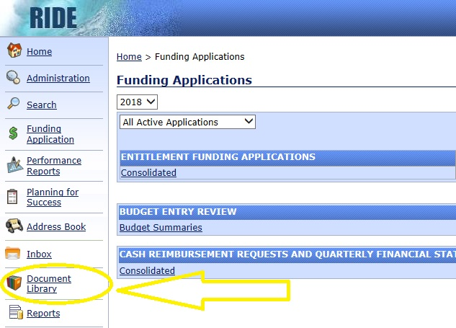
Choose the current year
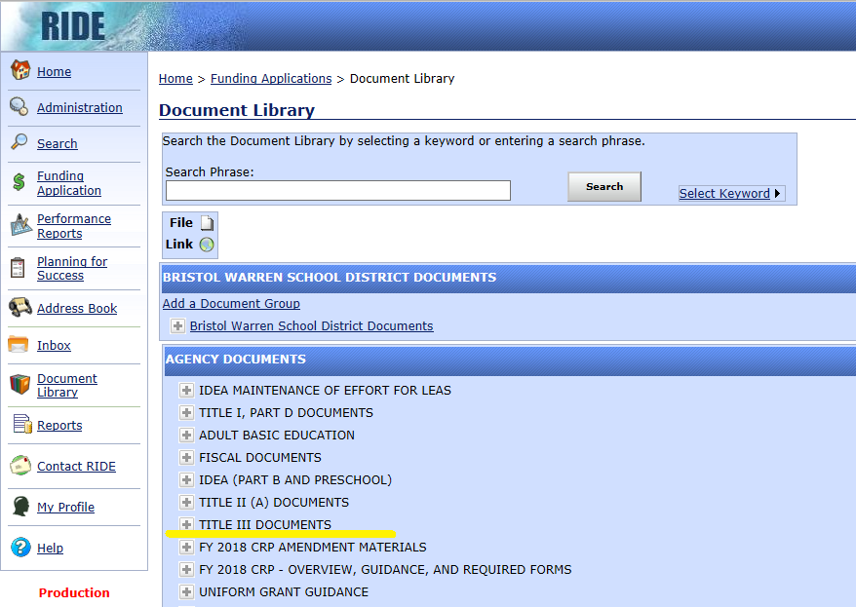

Private School Consultation

Districts are encouraged to review the various resources provided in the RIDE Document Library under Title III on Private School Consultation. View the Private Schools page in your grant to determine necessary consultations. Submit a form or evidence of attempts to collect the form for each school. RIDE collects counts of ELs even for private schools that choose not to participate in Title III Activities. The private school counts are used to compute the allocations to districts. These forms may be found in the Performance Review area.

Private School Consultation Requirements:
- Contact all private schools in district geographical region to ensure there is timely and meaningful consultation.
  - If a public school EL with a disability is placed using district or federal special education dollars in a separate special education program, this student is still a public school student. Private or non-public special education programs designed to serve as separate placements for children with disabilities do not fit under the private school consultation when their population is composed of publically funded and publically enrolled students.
  - When parents withdraw their children from public school and place them in a private school through privately paid tuition or scholarships, those locations are part of private school consultation under Title III.
- Discuss participation in Title III funded services for EL students and faculty in their schools. Title III services are only supplemental services, so core EL programming is never provided under Title III to either public or private school students.
- Private school students and teachers may receive benefits, services, and materials from these programs; although private schools do not receive direct funding from these programs. The LEA always maintains control of the funds.
- Submit evidence of consultation on RIDE form which can be found in the document library:
  - describe the private school participation in Title III activities
  - provide the district plan to evaluate the services provided to the private school
  - give a count of EL students in the private school by grade level
  - obtain private school official’s signature with intent to participate or not participate
  - SAVE the completed form to upload in the new Performance Report at a later date

Consortium Requirements:

- If the Title III allocation for the district is less than $10,000, the district must join an existing consortium or form a consortium with at least one other district in order to reach a combined total of $10,000 or more. Before the application is submitted, RIDE must receive a declaration of intent to join a consortium from each proposed member district. See sample Declaration of Intent in the RIDE document library.

- One of the districts must serve as the fiscal agent for the consortium. All participating LEAs must develop a memorandum of understanding (MOU) that outlines how the consortium will meet all Title III requirements, including private school participation procedures.


Up load your documents here.

Responsibilities of Fiscal Agents:
- The fiscal agent of the consortium must have on file from each district a memorandum of understanding that outlines how the consortium will meet all Title III requirements. Each MOU must be signed by the superintendent of the district agreeing to be a member of the consortium.
- The fiscal agent is responsible for all fiscal transactions of the consortium (requisitions, purchases, payments, etc.) and for maintaining records of all financial transactions carried out on behalf of the consortium.
- The fiscal agent is responsible for taking steps that result in all participating LEAs meeting their responsibilities under Title III to the ELs they serve.
- The fiscal lead is responsible for ensuring that all non-public schools within all member district boundaries are consulted and given the opportunity to participate in Title III activities in accordance with Title IX, Part E, Secs. 9501-9506.

The fiscal lead must use the drop down menus to account for private school participation for each member district.
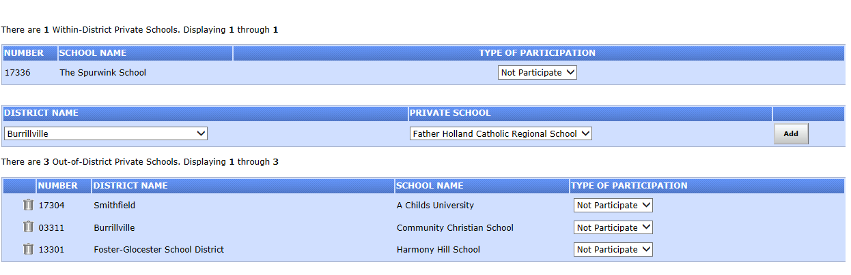

If an EL with a disability is placed in a special education private school, that student is still enrolled in public school systems and benefitting from IDEA and Title III funds like other public school students. Private school consultation does not apply to that separate placement special education setting. Private school consultation applies to students who are not enrolled in eRIDE and are not public school students.

Responsibilities of LEA members:
Consortium members must meet to discuss and develop a common plan that meets the requirements of Title III and other issues including the following:
- Needs of member districts for improving services for ELs
- Needs of member districts relating to professional development to improve instruction for ELs
- Common plan to effectively and efficiently use Title III funds to meet the identified needs of the consortium members

